2016写作大赛样卷
注：写作大赛初赛、复赛、决赛赛题均由两部分组成，分别为议论文+说明文/应用文/记叙文。其中，写作复赛第二部分需参赛选手在说明文/应用文中二选一，初赛和决赛需参赛选手在说明文/记叙文中二选一。
以下为四个类型的写作比赛内容、评分标准及样题。

类型1 议论文写作（Argumentative Writing）
比赛内容：选手完成一篇议论文写作（800词左右）。侧重考查选手的文献阅读理解、信息综合处理、判断分析、逻辑思辨、评价论述等能力，展示选手的知识广度、视野维度、思想深度等综合素质
评分标准（总分10分）：
Argumentative Writing
Content/  Ideas  (40%) | 1. Writing effectively addresses the topic and the task;  2. Writing presents an insightful position on the issue;  3. The position is strongly and substantially supported or argued.
Organization/  Development  (30%) | 1. Writing is well-organized and well-developed, using appropriate rhetorical devices (e.g. exemplifications, classification, analysis, comparison/ contrast, etc.) to support the thesis or to illustrate ideas;  2. Writing displays coherence, progression, consistency and unity;  3.Textual elements are well-connected through explicit logical and/orlinguistic  transitions.
Language  (30%) | 1. Spelling is accurate;  2. Writing displays consistent facility in use of language;  3. Writing demonstrates appropriate register, syntactic variety, and effective use of vocabulary.
Sample task 1
Read the following paragraphs which present contradictory views. Write a passage about the issue, clearly stating your opinion and explaining your reasons. You should write about 800 words.

The “Suspended Coffees” movement originated in small cafés in the Italian city of Naples and has since gained popularity around the world. The idea is quite simple: when you buy yourself a coffee at a café, you also pay for a second one — which can then be claimed by someone who cannot afford it themselves. They don’t have to “prove” anything in order to claim a coffee, as the scheme relies on the good faith of everyone involved. In China, some cafés and restaurants have also responded to the calls to offer “suspended coffees” and even “suspended meals” to people in need. But this has aroused some controversy.
Some people warmly embrace the idea and believe it passes on kindness and brings people happiness. They believe that compared to donating money, food or clothing, helping people in this way shows greater respect and dignity. Others, however, doubt the practicality of the idea in China despite its good intentions. Most of the “suspended coffees” and “suspended meals”, they argue, will not be claimed by people in real need since they are unlikely to have access to information about the movement or will be embarrassed or reluctant to admit their financial difficulties in public.
类型2 说明文写作（Expository Writing）
比赛内容：选手完成一篇说明文写作（600 词左右）。侧重考查选手解说事物、阐明事理的能力，以及运用知识、观察理解、梳理分析、提炼总结、跨文化沟通的综合能力。
评分标准（总分10分）：
Expository Writing
Content/Ideas  (40%) | 1. Writing effectively addresses the topic and the task;  2. Writing presents a clear thesis;  3. Writing maintains a formal style and an objective tone.
Organization/  Development  (30%) | 1. Writing is well-organized and well-developed, using appropriate development patterns (e.g., definition, illustration, casual analysis, process analysis, classification, comparison/contrast, etc.) to support the thesis or to illustrate ideas;  2. Writing displays coherence, progression, consistency and unity;  3. Textual elements are well-connected through explicit logical and/or linguistic transitions.
Language  (30%) | 1. Spelling is accurate;  2. Writing displays consistent facility in use of language;  3. Writing demonstrates appropriate register, syntactic variety, and effective use of vocabulary.
Sample task 2
Write a passage based on the chart below. The chart shows the hourly AQI (Air Quality Index) in Beijing, Shanghai and Guangzhou on the same day. In your writing, you should summarize the information by selecting and reporting the main features and make comparisons where relevant. You should write about 600 words.

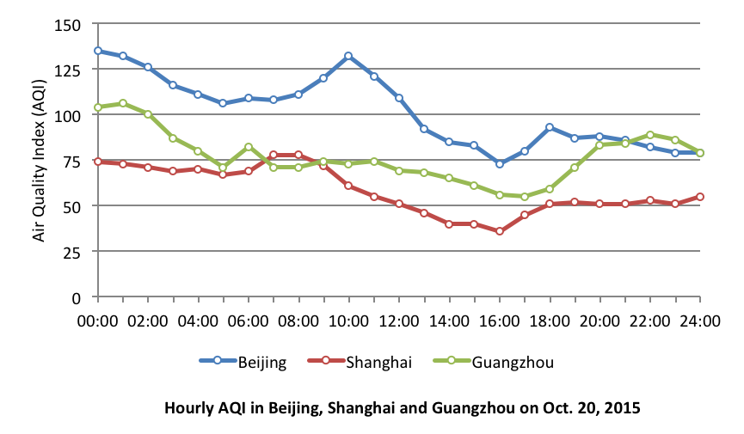

Note
AQI | 0–50 | Good
 | 51–100 | Moderate
 | 101–150 | Lightly polluted
 | 151–200 | Moderately polluted
 | 201–300 | Heavily polluted
 | >300 | Severely polluted

类型3 应用文写作（Practical writing；3选1，用于写作大赛复赛）
比赛内容：选手完成一篇记叙文写作（300 － 500 词）。侧重考查选手语言实际运用能力。
评分标准（总分10分）：
Practical Writing
Content/Ideas  (40%) | 1. Theme is strong and well-defined;  2. Writing requirements are well achieved;  3. Writing uses proper style, format and tone.
Organization/Development  (30% ) | 1. Writing is well-organized and well-developed, using appropriate development patterns (e.g., definition, illustration, casual analysis, process analysis, classification, comparison/contrast, etc.) to support the thesis or to illustrate ideas;  2. Writing displays coherence, progression, consistency and unity;  3. Textual elements are well-connected through explicit logical and/or linguistic transitions.
Language  (30%) | 1. Spelling is accurate;  2. Word choice is inventive, appropriate, and deliberate for illustrating the topic  and presenting character(s);  3. Sentence structure is varied and complex, and serves the purpose of writing;  4. Dialogue (when present) is believable, appropriate, and effective.
Sample task 3
Write a passage based on the chart below. You should write at least 300 words but no more than 500 words.
1. You have kept a bicycle in the entrance hall of the building. Many neighbors have complained it to you. Write an article to your gatekeeper.
1) You will describe your situation
2) Explain why you have to keep a bicycle there
3) Provide a solution to the problem
2. A new international hotel can supply varieties of working opportunities, writing a letter to apply for a certain sort of job.
Write about:
1) The reason you are writing
2) Why are you suit for a certain job
3) Show some certification about it
3. A night club just opened near where you live. You are very unhappy about the situation because it disturbs the peace of the neighborhood. Write a letter to your local governmental official. In your letter you can:
1) Introduce yourself;
2) Explain why you are unhappy;
3) Suggest what should be done about it.
You do NOT need to write any address. Begin your letter as follows:
Dear Sir or Madam,

类型4 记叙文写作（Narrative Writing）
比赛内容：选手完成一篇记叙文写作（600 － 800 词）。侧重考查选手的阅读理解、语言运用、细节描写、形象思维、创意构思、人文素养等综合能力。
评分标准（总分10分）：
Narrative Writing
Content/Ideas  (40%) | 1. Theme is strong and well-defined;  2. Setting, characters, and plot are fully fleshed out and connected;  3. Writing uses multiple subplots (if appropriate);  4. Ending is fitting and effective, and provides a sense of completion.
Organization/Development  (30% ) | 1. Flow of action is logical and deliberate;  2. Vivid and imaginative descriptive details are provided;  3. Writing reflects a unique, consistent personal voice;  4. Writing uses appropriate and varied rhetorical devices.
Language  (30%) | 1. Spelling is accurate;  2. Writing displays consistent facility in use of language;  3. Writing demonstrates appropriate register, syntactic variety, and effective use of vocabulary.

Sample task 3
Read the story starter and continue the story. You should write at least 600 words but no more than 800 words.
The Most Beautiful Flower
The park bench was deserted as I sat down to read beneath the long, straggly branches of an old willow tree, disillusioned by life with good reason to frown, for the world was intent on dragging me down.
And if that weren’t enough to ruin my day, a young boy out of breath approached me, all tired from play. He stood right before me with his head tilted down and said with great excitement, “Look what I found!” In his hand was a flower, and what a pitiful sight, with its petals all worn—not enough rain or light. Wanting him to take his dead flower and go off to play, I faked a small smile and then shifted away. But instead of retreating he sat next to my side and placed the flower to his nose and declared with overacted surprise, “It sure smells pretty and it’s beautiful, too. That’s why I picked it; here, it’s for you.”
The flower before me was dying or dead. Not vibrant of colors: orange, yellow or red. But I knew I must take it, or he might never leave. So I reached for the flower, and replied, “Just what I need.” But instead of him placing the flower in my hand, he held it mid-air without reason or plan. It was then that I noticed for the very first time that weed-toting boy could not see: he was blind.

